TECHNICAL REQUIREMENTS

1. **Project name**: ishGO - Job search system
2. **Team name and technology stack used**: Change makers | Java, Spring boot, JMIX
3. **Project purpose**
   1. Providing employers with permanent employees
   2. Creating a flow of candidates
   3. Providing suitable jobs for blue collar workers, women and people with disabilities (handicapped people), preventing migration (providing with AI)

**4. Conceptual model**

### 1. Users

1.1 Job Seekers

* Can search for job vacancies by category, industry and company.
* Can view job details (title, company, location, date posted, views).
* Can filter job vacancies.
* Can mark job vacancies as favorites.
* Can apply to categories of interest.

1.2. Employers

* Post job vacancies.
* Manage and edit job postings.
* Accept/reject candidates

### 2. Categories

* Predefined groups for filtering vacancies by type (e.g., blue collar, disabled, woman and so on).
* Allows users to search and receive notifications on specific categories in telegram bot.

### 3. Vacancies. Searchable and filterable by criteria (category, industry, company).

### 4. Search and Filter Features

* Search bar: Allows job seekers to search for specific job titles or companies.
* Filter: Based on job category, date posted, and other criteria.

### 5. Statistics

* Job posting statistics: Shows the number of vacancies posted daily, weekly, and monthly.
* User statistics: Tracks the number of views per job listing.

***Introduction***

The ishGO job search system aims to bridge the gap between employers and job seekers by providing a user-friendly platform tailored to the needs of blue-collar workers, women, and individuals with disabilities. The platform is designed to create a continuous flow of candidates, enabling employers to find permanent employees quickly and efficiently. By focusing on inclusivity and accessibility, ishGO helps reduce migration by offering local job opportunities, ultimately contributing to the country's socio-economic stability. The system supports multi-language options (Uzbek, Russian, and English) to ensure wide accessibility across different user bases. Easily write a job description and find a job using AI capabilities.

Languages

* Uzbek
* Russian
* English

**4. Functional requirements**

1. **Job Seekers**
   * Must be able to sign up and create a profile
   * Can apply to jobs with one click
   * Receive notifications for relevant job postings (based on filters or subscriptions).
   * Access job search history for quick re-application.
2. **Employers**
   * Can create an account
   * Must be able to post job vacancies with required fields such as job title, description, location, salary range, and employment type.
   * Can view applications and communicate with job seekers
   * Can accept/reject, invite candidates
3. **Statistics for Employers**
   * Employers must be able to view job posting analytics, such as how many candidates viewed and applied for each vacancy.

**4.1 Application Structure Requirements**

* **User Authentication**: Login with login and password or telegram
* **Job Posting Management**: Employers access an admin panel to post, edit and remove job listings.
* **Job Moderation**: Admins moderate job postings and ensure compliance with company policies before they go live.
* **Multi-language Support**: The system must be available in Uzbek, Russian and English.
* **Search Engine Optimization (SEO)**: Jobs and company profiles must be SEO-optimized to enhance visibility on search engines.

**4.3 User Classes**

1. **Admins**: Manage and moderate the platform, control job postings, and oversee system performance.
2. **Employers**: Post job vacancies, review candidate profiles and manage company-specific pages.
3. **Job Seekers**: Search and apply for jobs, manage their profiles.
4. **Guest Users**: Browse job listings but need to sign up to apply.

**5. Project Diagram**

UML diagram:  
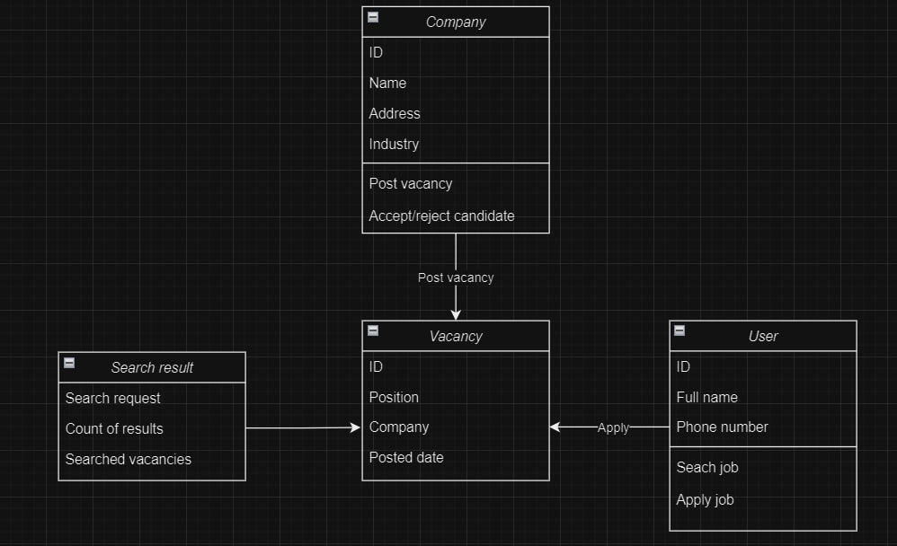

BPMN (Business Process Model and Notation)

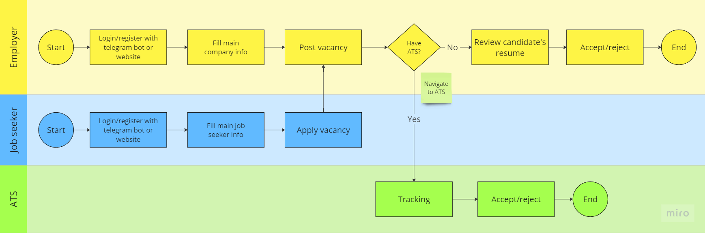

**6. Integrations**

1. **Telegram Bot**: Job seekers can find and apply to jobs easily.
2. **Th OLX, telegram, facebook, whatsapp, instagram:** employers can also post vacancy to this platforms to come huge flow of candidates
3. **ATS systems**: ishGO provides flow of candidates to ATS systems
4. **SEO and Google Analytics**: For tracking website traffic and optimizing job visibility.

**7. Technical Guide for Running the project**

**8. Additional Information**

* The website will be responsive, supporting both desktop and mobile devices.
* Regular updates will be made to the system to ensure security and functionality improvements.